Dinkarrao K. Shinde Smarak Trust’s,  DR. A. D. SHINDE  INSTITUTE OF TECHNOLOGY  Approved by AICTE, Delhi, DTE Mumbai and Govt. of Maharashtra, Affiliated to MSBTE, Mumbai. | 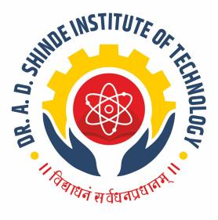
=========================================================================

DEPARTMENTAL TIME TABLE

Academic Year | 2025-26 | Program Name | CE
Semester | 2K | Class & Division | F

TIME/DAY | MON |  | TUE | WED | THU | FRI | SAT
09.45 - 10.45 | SUY |  | CHEM | SUY-A | CHEM | TEST | AMS
10.45 - 11.45 | EGM |  | EGM | SUY-A | BMC | EGM | PHY
11.45 - 12.15 | LONG RECESS
12.15 - 01.15 | SUY-A |  | PHY | PCO-A | AMS | PHY-A | CHEM-A
01.15 - 02.15 |  |  | SUY | PCO-A | SUY | PHY-A | CHEM-A
02.15 - 02.30 | SHORT RECESS
02.30 - 03.30 | AMS | EGM-A |  | AMS |  | BMC-A | BMC
03.30 - 04.30 | BMC |  |  | EGM | LIB | BMC-A

Course Name |  | Course Code | Course Abbr. | Name of the Faculty
Applied Mathematics |  | 312301 | AMS | Ms. Magadum S. S.
Applied Science | Physics | 312308 | ASC | Mrs. Patil S. B.
Applied Science | Chemistry | 312308 | ASC | Ms. Chavan K. K.
Professional Communication |  | 312002 | PCO | Mr. Kamble J. B.
Building Material and Construction |  | 312338 | BMC | Mr. Kamble A. S.
Engineering Mechanics |  | 312312 | EGM | Ms. Watangi S. R.
Surveying |  | 312339 | SUY | Mr.Patil.H.M

Batch A : 1 to 18

FACULTY HOD ACADEMIC COORDINATOR PRINCIPAL

