Dinkarrao K. Shinde Smarak Trust’s,  DR. A. D. SHINDE  INSTITUTE OF TECHNOLOGY  Approved by AICTE, Delhi, DTE Mumbai and Govt. of Maharashtra, Affiliated to MSBTE, Mumbai. | 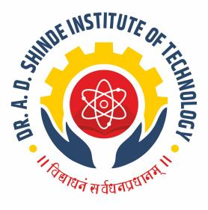
=========================================================================

DEPARTMENTAL TIME TABLE

Academic Year | 2025-26 | Program Name | ME
Semester | 2K | Class & Division | B

TIME/DAY | MON |  | TUE | WED | THU | FRI | SAT
09.45 - 10.45 | EGM |  | PHY-A  MPR-B | EGM | MPR | MPR-A  EDG-B | MPR-A  EDG-B
10.45 - 11.45 | MPR |  | PHY-A  MPR-B | MPR | EDG | MPR-A  EDG-B | MPR-A  EDG-B
11.45 - 12.15 | LONG RECESS
12.15 - 01.15 | EDG |  | CHEM | CHEM | EGM | EGM-A  CHEM-B | PCO-A  MPR-B
01.15 - 02.15 | AMS |  | EGM | AMS | AMS | EGM-A  CHEM-B | PCO-A  MPR-B
02.15 - 02.30 | SHORT RECESS
02.30 - 03.30 | PHY | EDG-A  PHY-B |  | LIB | CHEM-A  EGM-B | EDG-A  PCO-B | PHY
03.30 - 04.30 | AMS |  |  | TEST | CHEM-A  EGM-B | EDG-A  PCO-B

Course Name |  | Course Code | Course Abbr. | Name of the Faculty
Applied Mathematics |  | 312301 | AMS | Ms. Kamble P. S.
Applied Science | Physics | 312308 | ASC | Mrs. Patil S. B.
Applied Science | Chemistry | 312308 | ASC | Ms. Chavan K. K.
Professional Communication |  | 312002 | PCO | Mr. Kamble J. B.
Engineering Drawing |  | 312311 | EDG | Mr. Borgalli A. V.  Mr. Jangli V. G.
Engineering Mechanics |  | 312312 | EGM | Ms. Bhoi N. R.
Manufacturing Technology |  | 312313 | MPR | Mr. Sakhare S. S.

Batch A : 1 to 15 Batch B : 16 to 31
FACULTY HOD ACADEMIC COORDINATOR PRINCIPAL

