Dinkarrao K. Shinde Smarak Trust’s,  DR. A. D. SHINDE  INSTITUTE OF TECHNOLOGY  Approved by AICTE, Delhi, DTE Mumbai and Govt. of Maharashtra, Affiliated to MSBTE, Mumbai. | 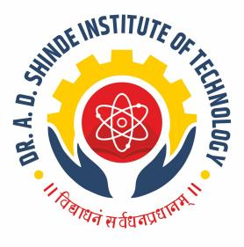
=========================================================================

DEPARTMENTAL TIME TABLE

Academic Year | 2025-26 | Program Name | TE
Semester | 2K | Class & Division | E

TIME/DAY | MON |  | TUE | WED | THU | FRI | SAT
09.45 - 10.45 | AMS |  | EWP-A  PCO-B | CPR | AMS | AMS | TEST
10.45 - 11.45 | CPR |  | EWP-A  PCO-B | BEL | BEL | EEE | LIB
11.45 - 12.15 | LONG RECESS
12.15 - 01.15 | BEL |  | AMS | EWP-A  WET-B | CPR-A  BEL-B | PCO-A  BEL-B
01.15 - 02.15 | EEE |  | BEL | EWP-A  WET-B | CPR-A  BEL-B | PCO-A  BEL-B
02.15 - 02.30 | SHORT RECESS
02.30 - 03.30 | BEL-A  EEE-B | WET-A  EWP-B |  | EEE | EEE-A  WET-B | WET-A  CPR-B | BEL-A  EWP-B
03.30 - 04.30 | BEL-A  EEE-B |  |  |  | EEE-A  WET-B | WET-A  CPR-B | BEL-A  EWP-B

Course Name | Course Code | Course Abbr. | Name of the Faculty
Applied Mathematics | 312301 | AMS | Ms. Magadum S. S.
Professional Communication | 312002 | PCO | Mr. Kamble J. B.
Programming in C | 312009 | CPR | Ms. Suryvanshi S.P.
Elements of Electrical Engg. | 312315 | EEE | Ms. Kamble S. P.
Basic Electronics | 312314 | BEL | Ms. Sutar A. U.
Web Page Designing | 312013 | WET | Mrs. Chandure S. D.
Electronics Workshop Practice | 312008 | EWP | Mrs. Nadagadalli N. A.

Batch A : 1 to 20 Batch B : 21 to 41

FACULTY HOD ACADEMIC COORDINATOR PRINCIPAL

